Unitech MS840B
Wireless Laser Scanner

New Product Introduction

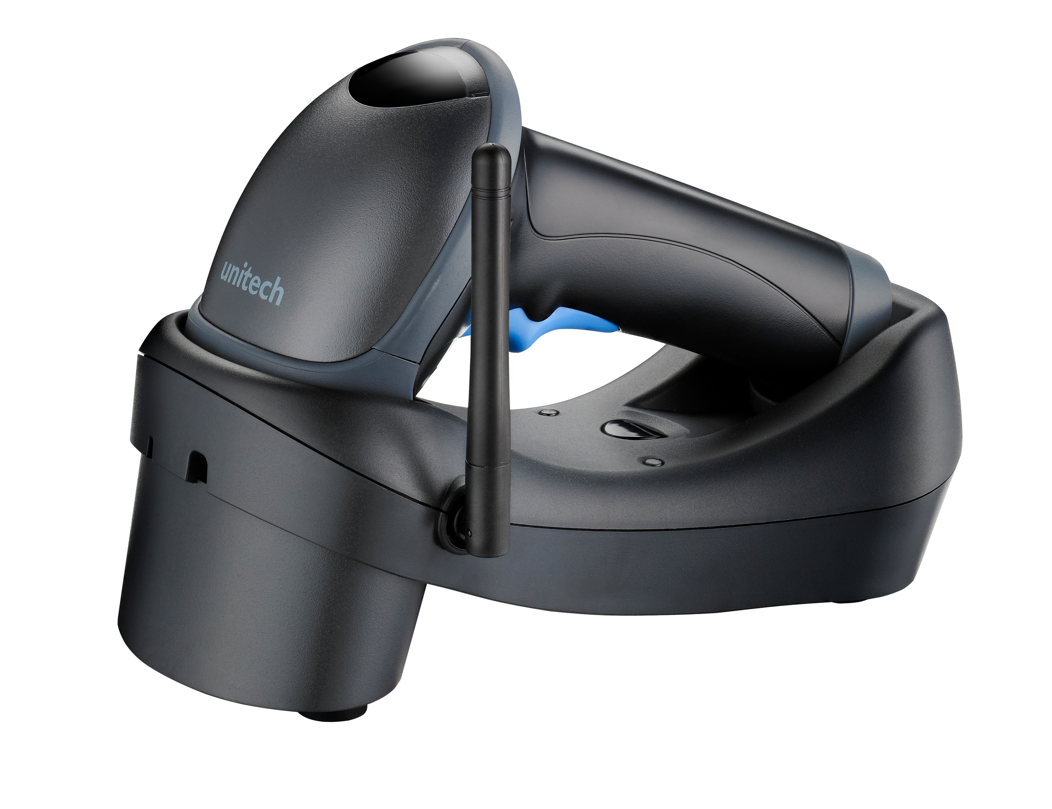

Prepared by: Tony Lin

Approved for release by:

Mr. Kwein Kao Mr. Pete Chen

Date: 2011/09/15 Date: 2010/09/15

This document to be released to RBU, list as below. Please arrange all appropriate personnel for operation. Thank you.

UTA
Mr. Vincent Shu, General Manager
Mr. Larry Ru, Product Manager
Ms. Susan Zheng, Product Management Coordinator
UTI
Mr. Jeffrey Huang, General Manger
Mr. Sjaak van Oosterhout, Technical Manager
Mr. Willian Shih, Sales & Marketing Manager
Ms. Yvonne Wang
UTT/UTP
Mr. Peter Shu, Vice President
Ms. Sophia Lin, Product Manager
Ms. Selina Shen, Product Manager
UTC
Mr. Johnny, General Manager
Mr. YunYang Chang, Jimmy Marketing Manager
Mr. Ryan Wu, Technical Manager
UTJ
Mr. Shinji Ijima, President
Mr. Shigeru Yama, Director

SBU Contact list

1.1 Product Management
Mr. Tony LIn tonyl@tw.ute.com
1.2 Order Coordinator
Ms. Diana Chien dianac@tw.ute.com
1.3 Product Service
Mr. Allan Chen allanc@tw.ute.com

1.4 Technical Support
Mr. Jim Wang jimw@tw.ute.com
Mr. Alex Yang alexy@tw.ute.com
1.5 RMA/ DOA
Mr. Patrick Chen patrickc@tw.ute.com
1.6 Marketing Communication & Development
Ms. Steffi Lee steffil@tw.ute.com
Ms. Daisy Lee daisyl@tw.ute.com
Table of Contents

I.
Executive Summary 1
II. product 2
1. Product overview 2
2. Spec 2
III. Product Positioning 3
1. internal position 3
IV. Pricing 4
list price 4
V. Promotion 5
1. Brochure 5
2. Sales Tools 5
3. PR & Press Release 5
4. Advertising 5
5. Exhibitions 5
VI. Warranty 4

I. Executive Summary

1. Product
Wireless scanning at its best
The new Unitech MS840B wireless laser scanner is enriched with a high-speed Mantis decoder and a powerful scan engine to optimize data capture efficiency. Supporting point-to-point and multi point-to-point use, the MS840B allows at least 3 guns to transmit and secure data to one cradle.

With a rugged wireless design, the MS840B provides greater flexibility and productivity for users to move without restrictions for real-time data connection, while also sustaining comfort over long periods of use. Able to scan up to 300-feet away from the host, the MS840B stores data in a buffer mode while it is out of range of the wireless signal, uploading the data when it gets back in range. Ideal for various applications in warehousing, retail and healthcare, the MS840B is easy to operate, able to take accurate inventory, speed up checkout, and administer the correct medication. Able to withstand multiple 6-foot drops to concrete and IP42-rated environmental seal against water and dust, the MS840B can maintain its high performance in the harshest environments.

Providing different configuration capabilities for USB, RS232 and PS2, connection is convenient with the MS840B. It also supports HID and SPP protocol, allowing users to connect to a PC or PDA directly. With a cradle that can mount to a desk or wall, a long life trigger design, and page calling for scanner tracking, the MS840B provides endless convenience and ease-of-use while lowering the overall investment cost so you can do more for your business.
Product Features
- High- speed Mantis decoder
- Long life trigger design
- One cradle supports up to 3 scanners
- Supports SPP & HID
- Buffer mode for out -of-range reading
- Page button on cradle for scanner tracking

2. Primary Target Markets

- Retail
  - POS system/check out
  - Inventory management
- Industrial
  - Shop-floor management
  - Inventory management
  - Shipment management
- Logistics & Transportation
  - Pick up and delivery management
  - Inventory management
- HealthCare
  - Patient/drug management
  - Inventory management

3. Product configuration & recommended pricing
Please see pricing section on Page 6.

4. Business ambitions and opportunities

The target forecast is over 3,000 pcs in the first year after NPI released.

5. Product Roll out

NPI | Otc/07, 2011
Marcom material : Brochure | Available now. Please refer to Portal Global
User’s Manual | Available now. Please refer to Portal Global
Global Website Announcement | Oct/14, 2011
Regional PR & Press Release | Arranged by RBU
Sales & Technical Training | Please refer to “MS840B Product Introduction” file in the attachment
VAR & Dealer Training | Arranged by RBU
Order Taking | Otc./14,2011
Material & Delivery | Available in Sep/1, 2011
II. Product
- Product Overview

The Unitech MS840B is a multi- functions rugged handheld wireless laser scanner.
Its ME design is based on MS840 with High durable and performance character .
MS840B extend its communication function by wireless technology which can read and transmit data to host over 300 feet without cable.
MS840B can connect to host by cradle which is easy to installation by plug and play. Also it can connect to host directly if host has built in wireless module.
MS840B has memory inside for out of range reading temporarily. The data will save to memory of scanner, when scanner back to range of connection, the data will send to host automatically or manually.
MS840B can support up to 3 scanner with one cradle.
It can meet most mobile applications in the market
.
For the more detail, please refer to “MS840B product introduction” file.

- Product Specification

Optical/Performance
Receiving Device | Laser engine
Light Source | Visible Laser Diode 650 nm
Max. Resolution | 0.127mm(5 miles)
Scan Rate | 100 scans/second
Skew Angle | ±50 degrees
Pitch Angle | ±35 degrees
Printing Contrast Scale | 45% Minimum
Reading Distance  (DOF PCS=90%) | Code-39 5mil  From 60 ~ 110mm  Code-39 6mil  From 50 ~ 130mm (± 10mm)  Code-39 10mil  From 50 ~ 230mm (± 30mm)  Code-39 20mil  From 50 ~ 380mm (± 30mm)  Code-39 40mil  From 70 ~ 550mm (± 50mm)
Functionality
Operation Mode | Trigger Mode, Flash Mode, Continuous Mode, Buffer mode
Symbologies | Code 39, Full ASCII Code39, Interleave 2 of 5, Standard 2 of 5, China Postal, UPC, Delta Code, MSI, Plessy, Codabar, Code 11, EAN8/13, Code 93, Code 128, EAN128, Code32, Italian Pharmacy, Label Code,GS1 databar code
Data Formatting | Prefix, Suffix, Code ID, Reformatting Date
Electrical
Operation Voltage | DC 3V~5V
Current Consumption | Operation mode:<170mA; Standby mode:<30mmA
Battery Type | Lithium-ion
Battery Capacity | 1620mAh charged via the cradle
Battery Charging time | Fully charged in 3 to 4 hours
Operating Time | Over 10 hours
Mechanical
Scanner Dimension | H176*W74*L89mm
Scanner Weight | 206g
Cradle Dimension | H73*W95*L200mm
Cradle Weight | 282g
Environmental
ESD Protection | Functional after 8K Contact and 12K Air
Mechanical Shock | 1.8M onto concrete
IP rate | IP42
Operating Temperature | 0°C to 50°C
Storage Temperature | -30°C to 70°C
Relative Humidity | 5% to 90% non-condensing
Communication
Radio Frequency | Unlicensed 2.4GHz,
Protocol | Bluetooth Class I,SPP & HID profiles
Range | 300 feet( line of sight)
Multi scanners operation | Up to 3 scanners to one cradle
Host Interface supported | Keyboard Wedge, RS232, USB(via Cradle)
Regulation Approvals
CE,FCC,BSMI,VCCI
Accessories
Cradle
Battery pack
Power adapter
Interface cable
Mounting Stand(on the Wall)

III.Product Positioning

- Market Position

List Price

Cipher 1226,$71010
USD800

LS4278 $667
USD700
MS9535 dd
USD600

MS840B
USD550
Cipher 1562,$55010
USD500

Functionality
IV. Pricing
1. MS840 List Price:
Model | Description | List Price
MS840-MUB0G0-SG | MS840/dark,MSL2001 laser ,BT, no cable ,no cradle, standard package | US$363  NTD$10,534
MS840-MUBBGC-SG | MS840/dark, MSL2001 laser, wireless, UBS cable ,with cradle, standard package | US$502  NTD$14,559
MS840-MKBBGC-SG | MS840/dark, MSL2001 laser, wireless, PS2 cable ,with cradle, standard package | US$561  NTD$16,281
MS840-MRBBGC-SG | MS840/dark, MSL2001 laser, wireless, RS232 cable ,with cradle, standard package | US$575  NTD$16,674

This price is base on 1 years warranty
The US$ is based on exchange rate: 29(For your reference only)
The exchange rate for ITP, please follow OP announcement quarterly.

2. Notice
Internal Transfer Price will be released to RBU by separate mail.

- Model Naming Rules
Opticon engine, Black ID | Series no. | Engine | Interface | Communication | Cable | Power supply | Accessary | Package | Green product
MS840(scanner only) | MS840B | Stand.Laser | None | BT | No cable | power | Cradle | standard | G
MS840-M0B0G0-SG | MS840B | M | 0 | B | 0 | G | 0 | S | G
MS840(USB cable) | MS840B | Stand.Laser | USB | BT | block str. | power | Cradle | standard | G
MS840-MUBBGC-SG | MS840B | M | U | B | B | G | C | S | G
MS840(PS2 cable)) | MS840B | Stand.Laser | Keyboard | BT | block str. | power | Cradle | standard | G
MS840-MKBBGC-SG | MS840B | M | K | B | B | G | C | S | G
MS840(RS232 cable)) | MS840B | Stand.Laser | RS232 | BT | block str. | power | Cradle | standard | G
MS840-MRBBGC-SG | MS840B | M | R | B | B | G | C | S | G

V. Promotion

- Brochure and Poster
English Brochure, please refer to NPI.

2. Sales Tools
MS840B Product Introduction (Power Point File) in the attached file.

3. PR and Press Release
To be arranged by Regional Business Unit.
Image file will be available upon request.

4. Advertising
To be arranged by Regional Business Unit.
Image file will be available upon request.

5. Exhibitions
The MS840B should be exhibited at all relevant trade shows with other scanners.

VI. Warranty
Unitech offers 1 years warranty
.

